React native is no doubt a very amazing Framework. Here you can make Android or IOS or any other platform application here
Its demand is also increasing very fast
Now you will ask that in Internet there are many courses some are paid and some are free and documentation is also available. Why to take your course
See it is a Complete React native Course and no topic will be missed here
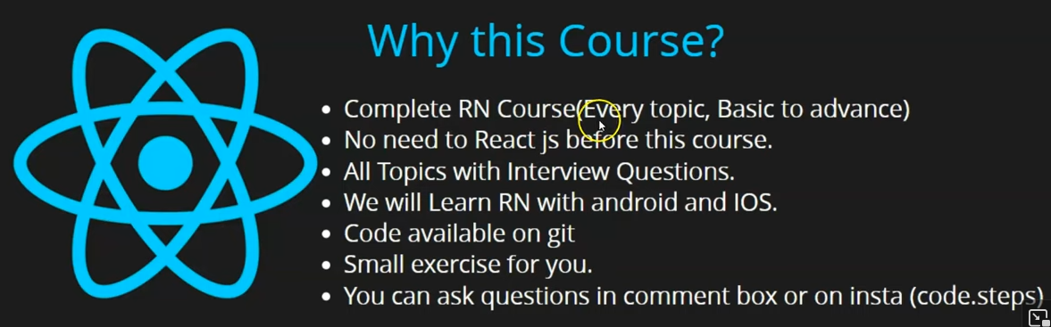
We will cover every topic with interviewer question, example and in last you will also see a project
and in react native we will implement redux
There is no need to learn React js before React native
Whatever concept of Reactjs is used in React native will be explained whether it is state, component ,props ,hooks or lifecycle method teacher will teach us everything
Whatever topics we will learn we will learn it with interview question
because Teacher aim is not to just teach you react native his aim is to also get you job.
Or if you currently have some job then you can increment it
We will study react native for both Android and IOS it is not like he will teach us in android simulator
We will learn about how to setup environment for Android and IOS in React Native
and how to seperatle create build for them
you can get the code used in each video by going to the github link given in the description of that video
and in between we will give you some exercise so that you can use your own logic
with react native code you can build small small thing by this your confidence will be build and it will help you to crack interviewer question
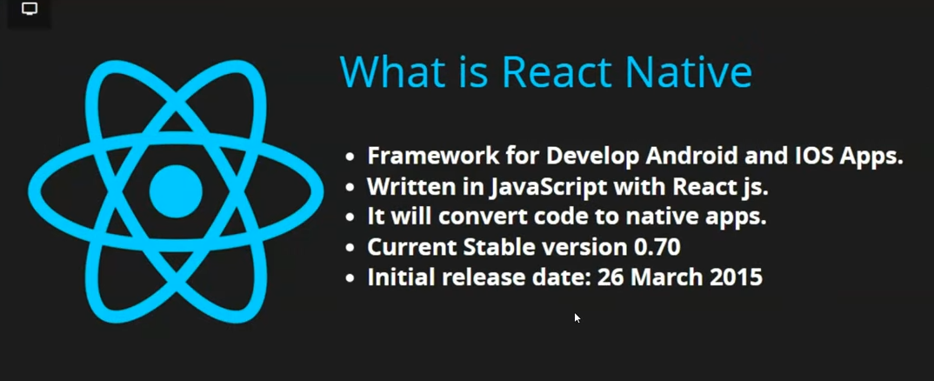
So now the question comes what is React native
See it is a framework to develop and build IOS and Android application
we can make another platform application but it mainly creates Android and IOS application
It is written in Javasctipt and Written in Javascript with React js.
Some people says it is written in React js you can say react js but inside React javascript is used
So it is not wrong to say javascript and React js.
Whatever code we write in pur react native when we make application or make build then it ge deployed in native code or get converted into it
If you have used older apps (made with native code by the developers) then you must have noticed that its look and feel was not good It looks like bekar saa toota phoota web based (i don't know)
In React native you will get look and feel whether you take button , input boxes whatever you see in it will appear as it is some native application like it is made in Android or IOS application and not made by javascript at all.
The current version for react native (accrording to teacher) is 0.70 (by the way now it is 0.76.1 of now)
Initial Release was in 26th March 2015
Now we will see Why to learn it
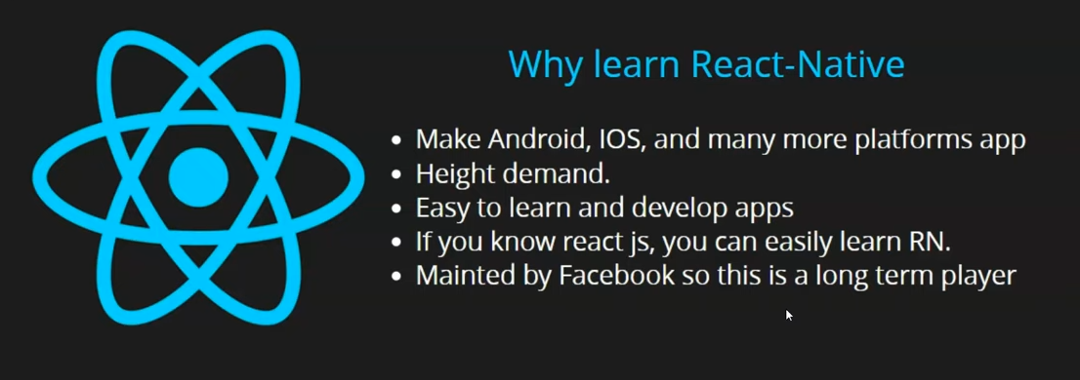
why not study other platforms why not study
PhoneGap:-
PhoneGap is an open-source mobile application framework. It allows developers to develop applications using standard web APIs.
Cordova:-
Cordova wraps your HTML/JavaScript app into a native container which can access the device functions of several platforms
Zembrain(who knows)
Because whenever we want to build android and ios application both then most of the companies prefer React Native because it gives very good look and feel that's why it has a very high demand
It is very easy to learn because it is comletely like javascript
It is not like you have to write different code for Android or differnt code for IOS
From one code you can make application for both the platform What more do you want.
If you know React then you can easily learn React native
You will become a mobile developer as well as Web developer
It is maintained by Facebook which is not a small company So such big comapny will give long term support so you can not say after 2 or 3 years there will be no scope something other will replace it Its scope will be in upcoming 10 or 12 years
Lets see some main topic of this course
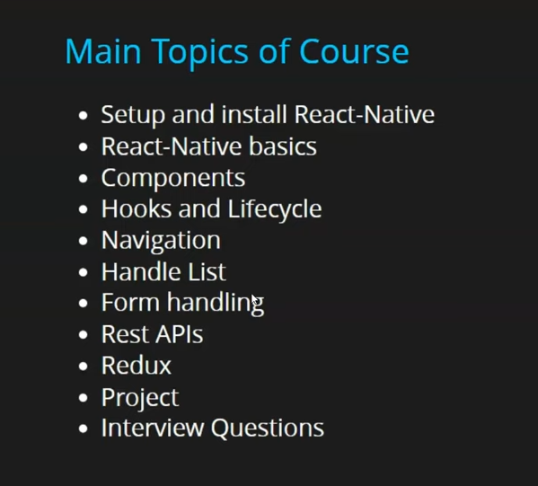
We will see how to setup react native in Android or IOS machine or anywhere else and then we will see the React native Basics whether it is state or component ,Hooks, Lifecycle methods ,props ,Navigation, and if we have a data list then how to handle it , How to build form validation
How to get the value of Textbox in the form How to do Form Handling How to integrate API ,
How to integrate redux in react native
and defineitely with every lesson you will get interview question
Note:-
Intial chapters are of javascript with react native and the others are of Typescript with Reaach Native

